1837 Mercer Co. formed. William Smith donates land for town spring and courthouse. He has 40 extra lots surveyed by Chrispianos Walker. Hence, North and South Walker Streets.
1839 original courthouse was built, but was torn down because of shoddy construction. It was rebuilt
1839 Bank was formed Princeton bank $25,000 stock
1840 Mercer Co. population about 2000, Princeton 320
1840 Dr. McNutt arrives, built house in 1842 `
1862 May 1, Princeton burned
1865 Judge Harrison comes to town Spurned by residents. Courthouse and records moved to Athens.
July, 1865 Dr. Isaiah Bee moves to Princeton
1874 County seat restored to Princeton
1872 Bank of Princeton incorporated and takes over assets and liabilities of previous bank. Bank important because it loans money. $25,000 in stock Harrison Straley, President
There were two stores in Princeton owned by John Smith and H. Scott. Eggs were bought for six cents a dozen chickens were $.10 a piece A Fox pelt was $75 possum skin was $25 a dozen and an otter pelt was $.50 apiece. Goods were brought from Hinton, which had a C&O station; it was a one-day trip down and a two day trip back, heavily loaded. They camped at Pipestem, which was named by Drury Farley. There were 19 houses, only two of which were weather bordered; there were no sidewalks, the streets were impassable for women and pedestrians walked in the middle of the street. The courthouse had exterior stairwell and court was opened by the sheriff blowing a ram’s horn, which was heard for 5 miles. There is one piano owned by Mary McNutt and only two buggies. The Board of Education refused to build a school for Princeton; they rented one room for all the grades; school was held from October to April and was heated by wood stoves. They had one water pail, with a dipper that all the kids used. There were no cards and no dancing or you were excommunicated by the Baptists and Methodists
1875 Courthouse built and burned, then a new brick courthouse was built
1881-1882 Baptists & Methodists build a church, which they shared. Cost $800 frame.
1882 N&W formed. They bought the John Higgenbotham 80 acre farm to build a rail yard in what became Bluefield. Bluefield was not incorporated until 1889. It only became a town because of the N&W railyard.
1885 Baptist Church sold for Black church, stands today. New Baptist Church built where memorial Building is now for $5000.
1889 Princeton Banking Co. formed then dissolved.
1889 Bluefield incorporated, growing by leaps & bounds
1891 Episcopal Church built; paid for by Mrs. Isaiah Bee. Bell tower added in 1908
1893 Bank of Mercer formed $25,000 stock
1894 Dr. McNutt dies
1894 County seat law passed by WV legislature. No county seat can be within 3 miles of state line, unless citizens vote to place it there. This was passed so that Bluefield could not easily take the county seat away from Princeton.
1900 Population between 900-100. There were 22 houses valued over $500.A new store was opened by Mr. Straley. It was nothing for them to do $500 worth of cash and $800 worth of credit sales per day.
1905 A 15-stall roundhouse for steam locomotives was completed in 1905 and soon afterwards a car repair shop, an erecting shops, and a reclamation plant were built for the Virginian Railway.
March 16, 1906 Election - Princeton had voting population of about 150, but 818 votes were cast. Princeton allowed railway workers to vote.
March 8, 1907 Deepwater & Tidewater combine to form the Virginian with no debt. From Mountains to sea, paying up front for the best.
1908 The Princeton Power Co. was formed in 1908 by Samuel J. Evans to provide electric power, coal, ice, and street railway service in Princeton, then with a population of 1,500. The Bluefield trolley cars were owned by what became Appalachian Power.

1908 Wooden bridge connecting Princeton & Goochville. It becomes East Princeton.

January 29, 1909 Spike at Glen Lyn connecting the Deepwater and Tidewater to form the Virginian Railroad.
April 1909 Henry Rogers, who provided the money for the Virginian rides from Sewell’s Point to Deepwater, through Princeton
December, 1909 A trolley line operated by the Princeton Power Company began operation of a line from the railroad station to the Court House, a total distance of 6,000 feet

1910 Census 3027 (Railroad shops and station are up and running.)
1912 Dr. Isaiah Bee dies.
1914 Trolley extended to Bluefield, WV
1914 Building starts near the railroad station. The majority of the businesses then expand from that location up to East Main Street The new street was named Mercer Street. The original business street was Walker Street (now N. Walker). It never expanded past the third block.
1920 Census 6224 (More than double 1910 census).
In 1920, the Princeton Power Company purchased the Bluefield Street Railway from the Appalachian Power Company, and sold its Princeton power plant to the Appalachian to help pay for the Bluefield trolley system. 1921s The trolley line had expanded and was providing interurban rail transportation between Princeton and Bluefield, WV and Graham, VA, thus providing travelers a way to make connections with the passenger trains of the Virginian Railway (in Princeton) and the Norfolk & Western Railway (in Bluefield).
Mid-1920s 195 workers were employed at the roundhouse, 285 at the car repair shop, 436 at the erecting shop, and 26 at the reclamation plant. The total average monthly pay-roll at the four shops was $106,000.
1922 Electrified tracks from Mullins to Roanoke, 134 miles, because of Clark’s gap grade; could only go 5 mph. The Virginian built a power plant at Narrows for its electricity for the railroad.
1925 Electric tracks completed; Cost $15 million; today’s money $214 million. The Virginian had 36 electric locomotive units.
1928 The name of the whole trolley operation was changed to the Tri City Traction Company
1930 Census 6955
1935 New present day courthouse built
1935 Post office built. Before was at people’s houses.
1937 The Bluefield city trolleys were replaced with buses in 1937 and the Princeton city trolleys were likewise replaced on September 17, 1940, but the interurban continued on. (See brick streets at Museum)

1940 Census 7426
1940 Memorial Building erected, now War Museum
Many of the side streets of Princeton, William Sanders wrote, were not paved until after World War II when City Councilman Robert Carr was very instrumental in pushing for them to be paved. Sanders’ mother came to Princeton from Bramwell in 1915, from a town with paved, cobblestone streets to a city which had main streets, which were dust in the summer and mud in winter and had board sidewalks on both sides of the street, including immediate frontage of the courthouse.
1947 All trolley cars abandoned in favor of buses.
1947 Current Thorn Street bridge opened. Bridge is due to be replaced by December, 2023.
1950 census 8279
Between 1954-1957 VGN bought 66 diesel engines.
1957 Virginian eliminated steam engines
1959 N&W buys VGN, last passenger service out of Princeton
1960 census 8393
1960 N&W starts laying off & transferring people
1970 census 7253
1979 Station torn down
1980 census 7538
1990 census 7043
1991 Shops totally closed down
2000 census 6347
2006 Princeton Railroad Museum is built
2007 Last of shops torn down, except WV Recycles
2010 Census 6432
2020 Census about 5800
2022 Princeton Railroad Museum is 16 years old.

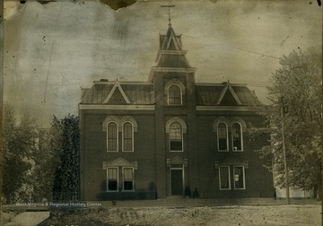
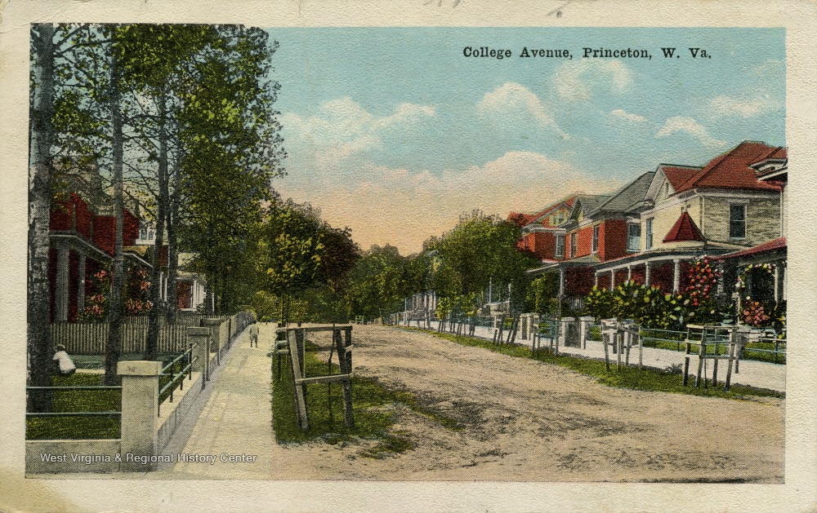
LOWER MERCER STREET NEAR RAILROAD MUSEUM
107 Mercer St. 1923
Trolley barn 1938
110 Mercer St.1911
112 Mercer St.1950
Old Hotel 1910
Old Stag 1920
200 Mercer St 1950
222 Mercer St 1915
Princeton Hotel 1910
316 Mercer St 1912
Princeton Manor 1923
325-327 Mercer St 1923
Hillbilly Cycle 1930
Hillbilly Cycle 1940
311 Mercer St.1915
309 Mercer St.1915
Dry Cleaners 1915
301 Mercer St 1915 Shumate Furniture
Hotel, originally a bank 1915
Harvey’s Paint & Supply 1923
Harvey’s Auto Supply 1930
221-225 Pool room 1915
217 Mercer St 1915
207 Mercer St 1913
Mullins Brothers 1912
Wheby’s Grocery 1926
Bollings Storage 1930

