COAL ON THE MOVE
There is no finer coal anywhere in the world than that produced along the Virginian Railway and its connections – coal in abundance for metallurgical, coking, steel making, and producing electricity.
Although coal was mentioned in the Old Testament and was used by ancient Chinese, Greeks and Romans, it was not mined on a large scale until comparatively modern times. The first commercial mine in this country was opened above Richmond, VA in 1750. Early settlers in what is now WV knew something about the coal beneath them, but little was done about mining until the late 1800s.
Coal Mining
There are two ways to remove coal from the ground: surface mining and underground mining.
Surface mining is used when a coal seam is relatively close to the surface, usually within 200 feet. The first step in surface mining is to remove and store the soil and rock covering the coal (called the "overburden"). Workers use a variety of heavy equipment--draglines, power shovels, bulldozers, and front-end loaders-to expose the coal seam for mining.
Underground mining is used when the coal seam is buried several hundred feet below the surface. In underground mining, workers and machinery go down a vertical "shaft" or a slanted tunnel called a "slope" to remove the coal. Mine shafts may sink as much as 1,000 feet deep.
After coal comes out of the ground, it typically goes on a conveyor belt to a preparation plant that is located at the mining site. A "prep" plant cleans and processes coal to remove dirt, rock, ash, sulfur, and other impurities. Removing the impurities increases the heating value of coal.
After the coal is mined and processed, it is ready to go to market.
Coal became the largest source of energy in the 1880s, when it overtook wood, and remained the largest source until the early 1950s, when coal was exceeded by petroleum.
What changed? The coal was there, but a vital factor was missing – speedy, dependable transportation. Then Virginian Railway was formed in 1906, specifically to haul coal out of southern West Virginia to the Atlantic coast, where it could be loaded in ships and transported almost anywhere in the world.
However, all the Virginian’s coal was not destined to the piers. The coal rails directly served a variety of industries dependent on the WV mines for fuel. There were two huge electric plants along the Virginian’s main line that required a huge amount of coal and the steel industry took a high percentage of the Virginian coal tonnage. Chemical firms of all descriptions, wallboard, cement manufacturers, textiles and scores of other users of the magic mineral were located on or near the Virginian lines.
Coal provided more than half of the nation's energy from the 1880s to the 1940s, and from 1906 to 1920 provided more than three-quarters of US energy.
The need to maintain coal supplies (a primary energy source) had figured in both world wars.
WORLD WAR I
The first World War was won by the Allies because of WV coal. Before America entered the war, it was sending supplies to the Allied side. German U-boats attempted to cut the supply lines between North America and Britain. The nature of submarine warfare meant that attacks often came without warning, giving the crews of the merchant ships little hope of survival. The United States launched a protest, and Germany changed its rules of engagement. Finally, in early 1917, Germany adopted a policy of unrestricted submarine warfare, realizing the Americans would eventually enter the war. Germany sought to strangle Allied sea lanes before the United States could transport a large army overseas, but after initial successes eventually failed to do so. The German ships followed the smoke trails of US ships and fired on them. That’s when WV coal saved the day. The coal from southern WV was “smokeless” bituminous coal and did not leave a trail, so US troop and supply ships could cross the Atlantic Ocean without being detected. When the US sent thousands of troops, it turned the tide of the war and Germany was defeated, thanks to WV coal carried from the mines of southern WV to the Atlantic coast via the Virginian railroad tracks. An armistice was declared on November 11, 1918.
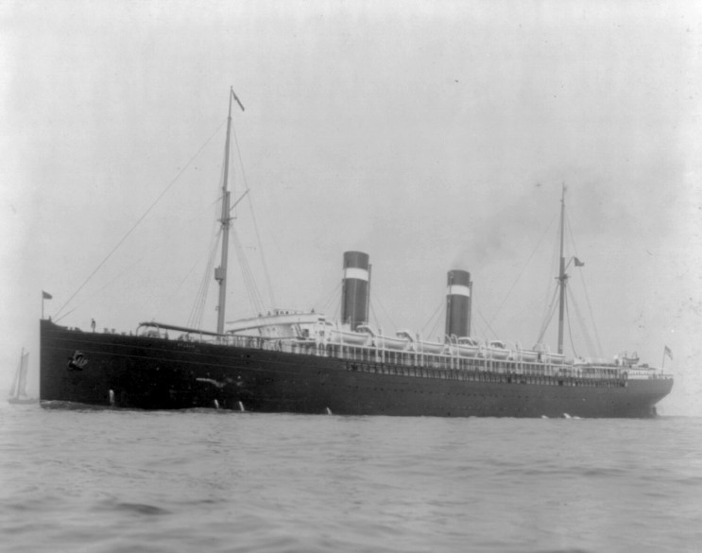 On 17 April 1918, St. Louis was delivered to the Navy at New York to be wholly manned and operated by the Navy as a troop transport. She was renamed Louisville (SP-1644), as a cruiser named St. Louis was already in service in the Navy. Louisville was commissioned on 24 April. Notice the slight smoke trails from using WV Coal.
Coal in World War II
Coal was critical to the war effort. Coal was the single largest raw material industry; by value it was significantly larger even than iron and steel industries and its uses were many: it was the basic energy source, the source of power for locomotives, raw material for iron and steel production, armament production and used for producing electricity. Coal was also gasified to produce coal gas, also known as "town gas". Coal gas is combustible and was used for municipal lighting, and heating, before the advent of large scale production of natural gas from oil wells.
Coal was the most important energy source in the world during the time of World War II. And the Virginian Railway was one of the primary transports.
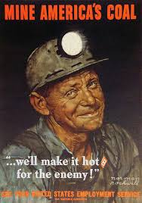

A typical view on the adjacent track in 1940-1959.
How Coal Is Used today
What do we use coal for? Electricity is the main use. Last year 88 percent of all the coal used in the United States was for electricity production. (Other energy sources used to generate electricity include nuclear power, hydropower, and natural gas.)
Another major use of coal is in iron and steelmaking. The iron industry uses coke ovens to melt iron ore. Coke, an almost pure carbon residue of coal, is used as a fuel in smelting metals. The United States has the finest coking coals in the world. These coals are shipped around the world for use in coke ovens.
Coal is also used by other industries. The paper, brick, limestone, and cement industries all use coal to make their products.
The Virginian Railway was purchased by the Norfolk & Western railroad in 1959. That railroad was combined with the Southern Railroad to make the Norfolk Southern, which is the railroad tasked with hauling coal out of southern WV today.

