LOCOMOTIVE ENGINES OF THE “Richest Little Railroad In The World”
The profitable VGN experimented with the finest and largest steam, electric, and diesel locomotives. It was well known for operating the largest and best equipment, and could afford it. VGN sought (and achieved) the best efficiencies in the mountains, rolling piedmont and flat tidewater terrain.
It became nicknamed "the richest little railroad in the world."
Through the course of its 50 year history as the “richest little railroad”, the Virginian used three types of engines to haul coal trains from the mountains of WV to the Tidewater area of Virginia to awaiting ships. The Virginian even had its own tugboat to help bring the large ships into the harbor at Sewell’s Point, VA.

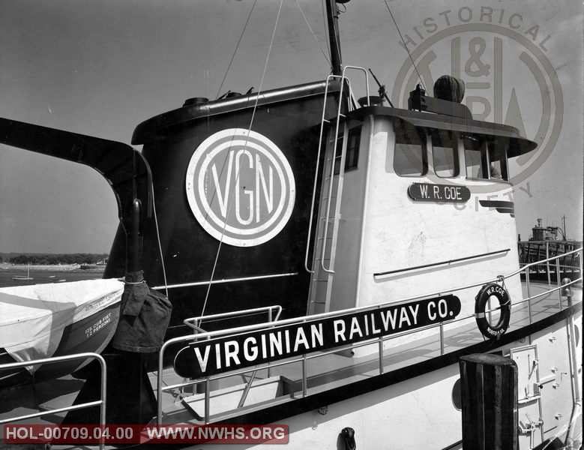

Steam Locomotives
The first type of engine that the Virginian used from its inception was the steam engine. The first railroads were little more than tracks on roads; horses pulled wagons and carriages with their wheels modified to ride on the rails. Trains could not be moved by steam power until the steam engine could be mounted on wheels. The first steam locomotives were built in England, the birthplace of steam power, and the first locomotives in America were imported from England. Soon, however, Americans began to plan their own locomotives.

How a steam engine works
Crudely speaking, there are four different parts in a steam engine:
- A fire where the coal burns.
- A boiler full of water that the fire heats up to make steam.
- A cylinder and piston, rather like a bicycle pump but much bigger. Steam from the boiler is piped into the cylinder, causing the piston to move first one way then the other. This in and out movement (which is also known as "reciprocating") is used to drive...
- A machine attached to the piston. That could be anything from a water pump to a factory machine... or even a giant steam locomotive running up and down a railroad.
- 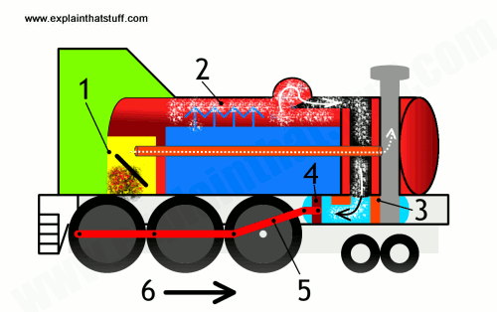

The Virginian was often in the forefront of steam locomotive development, particularly in the area of LARGE articulated locomotives. The most (in)famous was the class XA Baldwin Triplex. This was built expressly for pusher service up the Clarks Gap grade. Unfortunately, its appetite for steam exceeded the capacity of its boiler. It was returned to Baldwin after extensive field trials, and was rebuilt into two smaller locomotives.

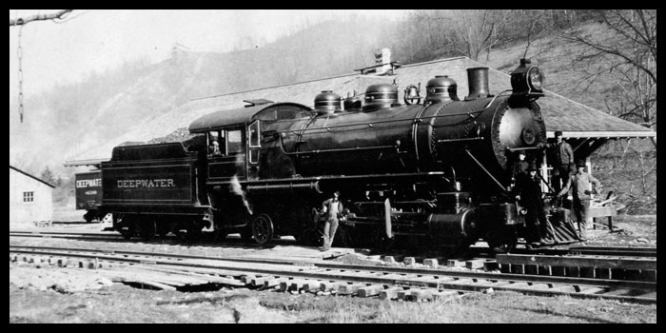
One of the Deepwater’s early locomotives. The Deepwater combined with the Tidewater to form the Virginian Railway in 1909.
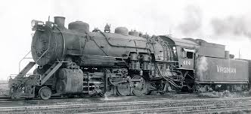VGN 215 Steam 4-6-2
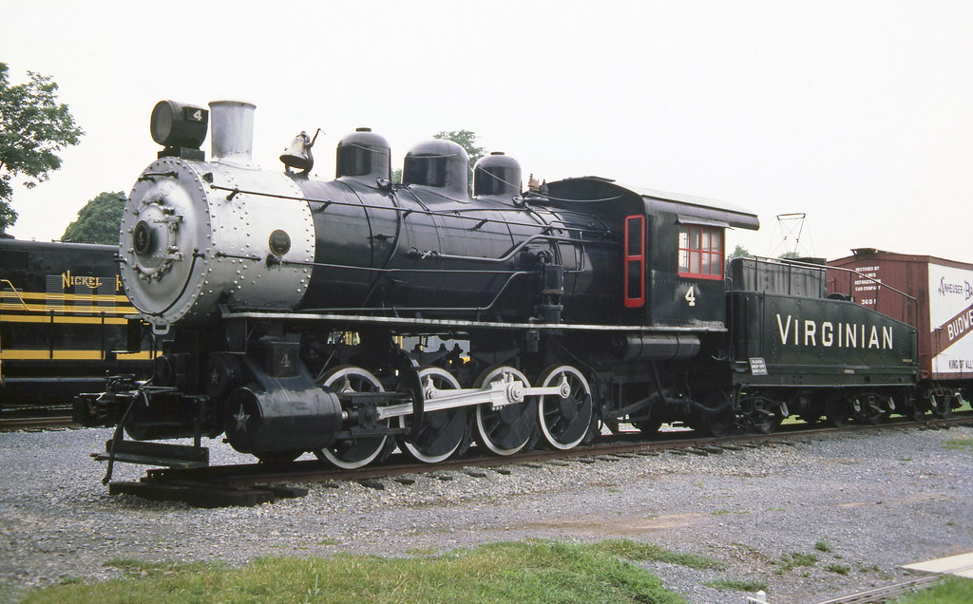
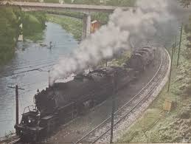
From the early 1900s, steam locomotives were gradually superseded by electric and diesel locomotives, with railways fully converting to electric and diesel power beginning in the late 1930s. The majority of steam locomotives were retired from regular service by the 1980s, although several continue to run on tourist and heritage lines.

Operating and Electrifying "the Richest Little Railroad in the World"
As the coal traffic on the Virginian began to mushroom by 1920, it became clear a better solution had to be found to get the loaded coal trains out of West Virginia. The grade at Clark’s Gap, west of Princeton, was the steepest and a bottleneck to operations. And it was expensive to operate in its then-current condition. Huge steam locomotives were being used and the trains were slow. At the railroad’s Board of Directors meeting in the spring of 1923, it was decided to commence work to electrify a portion of the railroad. Engineering and design work commenced Nov. 29, 1923 after Virginian’s hiring of the engineering firm of Gibbs & Hill of New York City, generally identified as pioneers in railroad electrification. One hundred and thirty four miles of the mainline would be electrified. To electrify a railroad, you needed a source of power, so the Virginian started building a power plant in Narrows, VA. The firm immediately erected a field office at Narrows before construction of the power plant started
Narrows, Virginia was chosen as the site for the power plant because the town was already there and it was half way between the extreme ends of the electrified territory; Mullens and Roanoke. The plant’s primary building was 220 feet by 156 feet and roughly 140 feet high. Two brick stacks stood 376 feet tall. There were three turbo generators with a fourth available as needed, each capable of producing 15,000 k.w of electricity. The 45,000 kilowatts to 60,000 kw produced at the plant in 1925, before any upgrades or modifications, would be sufficient to power the entire City of Princeton, West Virginia in 2010.
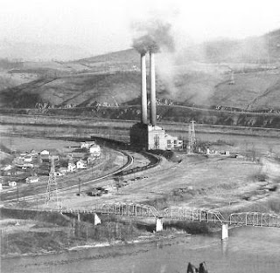
Former VGN coal fired power plant located at Narrows, VA, about seven miles east of Glen Lyn. The plant supplied electricity for the entire electrified territory. It was shut down on June 30, 1962 at the end of electrification. The structure was dismantled in the early 1970’s
To construct the overhead and functioning electric lines for the 133.6 miles of electrified railroad, the railroad directors approved $5,964,973 for catenary in Virginia and $1,977.292 for catenary in West Virginia. A catenary is a system of overhead wires used to supply electricity to a locomotive or streetcar.

THE ELECTRIC RAILROAD
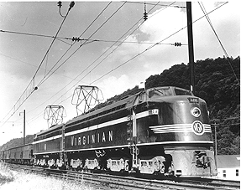
The Virginian Railway was one of the last great systems built in this country. The vision of oil tycoon Henry Rogers and engineer William Page, it had but a single purpose, hauling coal. Constructed to extremely high-standards, its main line was less than 500 miles, but a constant irritation to the much larger Norfolk & Western. Despite its small size, the Virginian operated with precision-like efficiency, handling black diamonds from tipple to tidewater. Formed at the turn of the 20th century, it opened within a few years of its inception, thanks to Mr. Rogers' deep pockets. Mr. Rogers answered to no one, as the Virginian was constructed with his own money; he wanted the best coal railroad money could buy and he got it. Where other railroads went around the mountains, Mr. Roger’s Virginian went through the many mountains of West Virginia and Virginia. At one point in time, he had 10,000 men working to complete his railroad. After completion of the railroad, the Virginian Railroad ran into a problem at Clark’s Gap in Wyoming County, WV. The mountain was impenetrable and the grade was very steep. The steam engine, hauling a load of coal cars, could only go about 14 miles per hour up the grade. Since time was money to the coal barons, the Virginian found a way to speed up that route. During the 1920s, a section of main line west of Roanoke, Virginia to Mullens, West Virginia was electrified and the railroad truly shined. At first, box cabs were utilized and then later much more powerful rectifiers from General Electric arrived. During the first half of the 20th century, the pros and cons of railroad electrification were widely debated within a conservative industry where steam ruled supreme.
Proponents argued that electric-powered trains were cleaner, quieter and more efficient to operate. Electric motors provided greater starting power than steam power. And, electrified operations could lower labor costs and increase speed because there was no need to stop for coal, oil and water.
In 1923, Virginian management instituted a project to electrify its main operational bottleneck, the limiting grade of Clarks Gap Hill. (The actual area electrified was from Mullens, WV to Roanoke, VA.) The initial installation was an evolutionary improvement of technology used on the much shorter N&W Elkhorn grade line. Power was supplied by a coal-fired power plant at Narrows, Virginia. The original boxcab-style EL-3A electric locomotives were built by a consortium of Alco (American Locomotive Company) and the Westinghouse Electric and Manufacturing Company. Two later classes, EL-2B and EL-C, were built by General Electric in 1948 and 1956 respectively.
The Virginian's electrification constituted the longest stretch of mountainous electrification in the eastern United States. The electrification project was written up extensively in the railroad trade press at the time
Skeptics balked at the expense of building generating plants and maintaining a spider web-like network of overhead catenary wires. They also raised safety concerns about the hazards posed by high-voltage lines. In almost every instance, electrification was beneficial to the bottom line. Running times were reduced and tonnage capacities were increased. Fuel and maintenance costs were lowered, and the service lives of electric locomotives proved to be twice as long as those of steam locomotives.
According to Thomas Edison, electric locomotives offered numerous advantages, including “no grinding, no jerking, no puffing, no pulling, no straining, no distant slumbers—just a keen sense of moving swiftly, of being propelled by power vastly in excess of requirements. You ride with ease—you are at ease—it is the very last word in transportation.” The heyday of all-electric locomotives ended after World War II with the advent of reliable, cost-effective diesel machines. The 1950s was a transition decade for the railroad industry as steam power quickly succumbed to diesel technology, which offered numerous advantages.

The electrification was completed in 1925 at a cost of $15 million, equal to $221,356,736 today. ALCO and Westinghouse supplied the first electric locomotives, which were equipped with pantographs, as shown below.
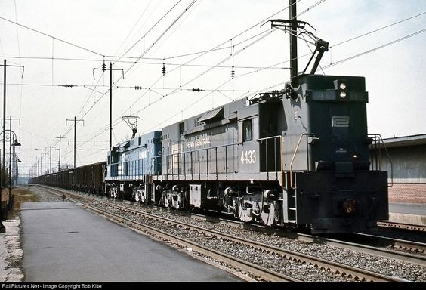
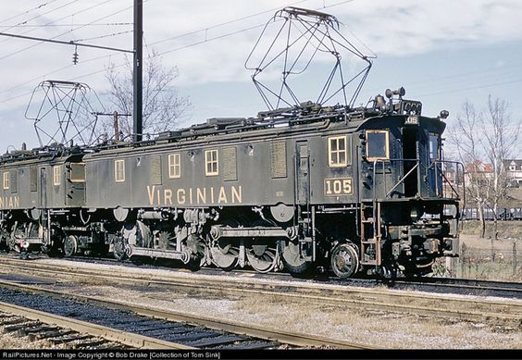

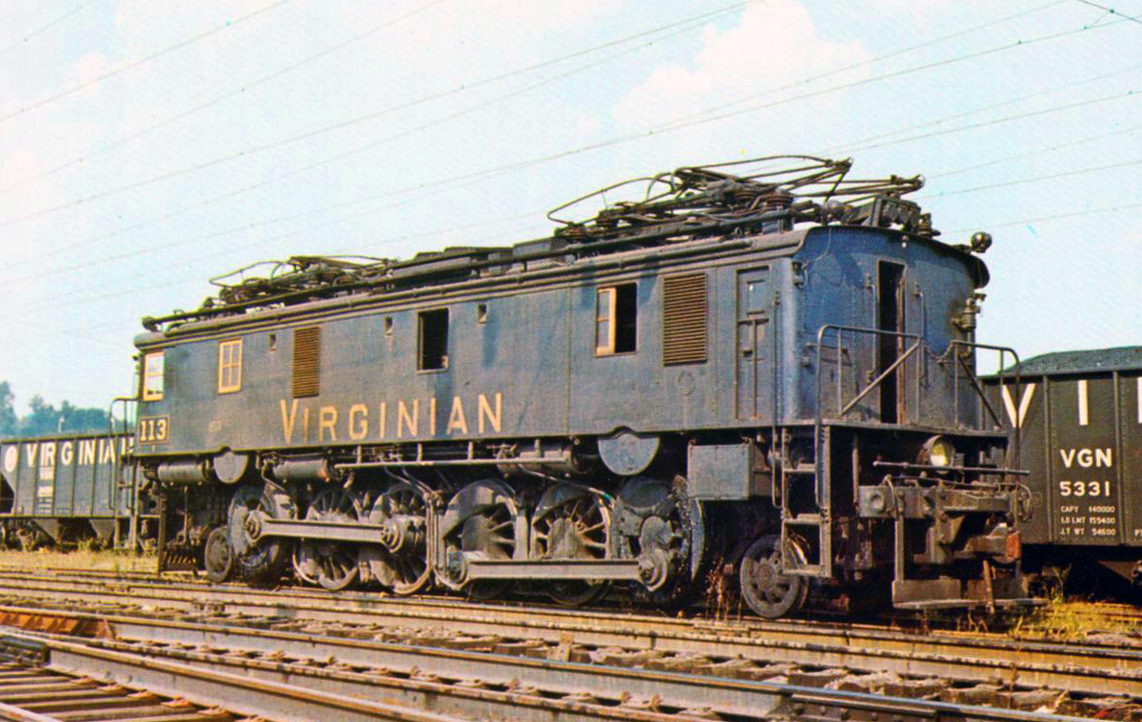
Virginian Railway boxcab #113 (Class EL-1a) sits quietly under the wires at Princeton, West Virginia circa 1957.

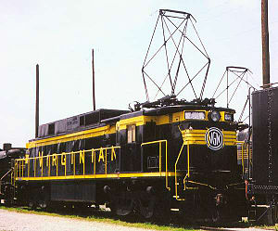
EL-C
To supplement its aging boxcabs, which were reliable and effective, but hard on the track, the Virginian turned to General Elactric. In 1948, four huge EL-2B twin-unit locomotives were purchased followed by twelve EL-C rectifier locomotives in 1955.
The Virginian Railway’s EL-C rectifiers were the most advanced electric locomotives the railroad ever owned.
Built in the late 1950s by General Electric, they produced over 3,000 hp and were quite adept at hauling coal out of the southern West Virginia mountains.

THE “Richest Little Railroad” converts to DIESEL
1895: Diesel's engine patent is granted in the United States on July 16, 1895.

1898: With Diesel's help, the first commercial engine is built in a factory in St Louis, Missouri, United States by Adolphus Busch (1839–1913), brewer of Budweiser beer.
1939: General Motors unveils its EMD FT, a powerful diesel-electric locomotive, and sends the first one (Number 103) on a year-long voyage to demonstrate its worth. Proving beyond doubt the superiority of diesel, this sounds the death knell for steam locomotives.
In the mid-1950s VGN management realized that the company's devotion to coal as its energy source (for steam locomotives and the power plant at Narrows for the electrification system) was becoming overshadowed by the economies of diesel-electric locomotives and a scarcity of parts for the older steam locomotives. Many railroads engaged in long-term experimentation during the era of dieselization, ordering a few units from each of the several builders of the day. The Virginian went totally the other direction, ordering diesels from Fairbanks Morse almost exclusively. The lone exception was one General Electric 44-Tonner, purchased specifically for industrial and interchange service in the Suffolk, VA area.
The VGN built these to the heaviest standards of the time in order to accommodate the heavy tonnage which it hauled.
Diesels were easier to operate and required only one operator, which provided greater ease in switching and yard operations. They were quieter, operated in all types of weather, and offered climate-controlled cabs for an improved work environment. Diesels were altogether more convenient. It takes hours to fire up a steam engine before you can use it; you can get a diesel engine running in less than a minute and they incurred no costs due to downtime

Between 1954 and 1957, a total of 66 diesel-electric locomotives were purchased, including 25 Fairbanks-Morse H-24-66 Train Masters, and 40 H-16-44 smaller road switchers, two with steam generators to haul passenger trains. The last steam locomotive operated in June, 1957.
At the end of 1925, VGN operated 545 route-miles on 902 miles of track; at the end of 1956, mileages were 611 and 1089.
The tiny Class 1 railroad was very profitable and became known as the "Richest Little Railroad in the World." Of course, the VGN's more modern gradient and facilities and profitability were all coveted by the competition. There were many attempts to acquire it. All failed throughout the first half of the 20th century. Finally, as the Interstate Commerce Commission began to realize that railroads needed to be able to compete successfully with trucking and other modes of transportation more than primarily each other, in 1959, the Norfolk and Western succeeded in reaching a merge with the VGN and gaining regulatory approvals, marking what became called the "modern merger era" in North American railroading which eventually resulted in Princeton's current service by Norfolk Southern Railway, one of only 6 large class 1 railroads operating in the United States in the 21st century.
The VGN was merged into the Norfolk & Western in 1959. However, almost all of the former VGN mainline trackage in West Virginia and about 50% of that in Virginia is still in use today, as the preferred route for eastbound coal trains for Norfolk Southern Corporation due to the more favorable gradients while crossing the Allegheny Mountains' continental divide and the Blue Ridge Mountains east of Roanoke, while most westbound traffic of empty coal cars uses the original Norfolk and Western main line.

Deepwater Railway and Tidewater Railway
Originally, the Page-Rogers scheme was a short line railroad, the Deepwater Railway, formed in 1898, an intrastate line intended to be only in West Virginia. Eventually, after establishing relationships to interchange coal traffic with the bigger railroads failed, the Deepwater's right-of-way was extended to reach the West Virginia-Virginia state line near Glen Lyn, Virginia. Important points on the Deepwater Railway were Page, Mullens and Princeton in West Virginia.
In Virginia, another intrastate railroad, the Tidewater Railway, was formed in 1904, with right-of-way across the southern tier of Virginia from Giles County (which borders West Virginia) to Norfolk County on Hampton Roads. The principal points were Roanoke, Victoria, Suffolk, and Sewell's Point, a rural location where a new coal pier was located on the harbor near Norfolk.

Last spike, celebrations
The last spike in the Virginian Railway was driven on January 29, 1909, at the west side of the massive New River Bridge at Glen Lyn, near where the railroad crossed the West Virginia-Virginia state line.
In April 1909, Henry Huttleston Rogers and Mark Twain, old friends, returned to Norfolk, Virginia together once again for a huge celebration of the new "Mountains to the Sea" railroad's completion.
Rogers departed the next day on his first (and only) tour of the new railroad. He died suddenly six weeks later at the age of 69 at his home in New York. By then, the work of the Page-Rogers partnership to build the Virginian Railway had been completed.
While neither William Page or Henry Rogers operated the railway, it was arguably a crowning achievement for each man. Together, they had conceived and built a modern, well-engineered railroad from the coal mines of West Virginia to tidewater at Hampton Roads. The Virginian Railway operated more efficiently than its larger competitors, had all-new infrastructure, and no debt. It was an accomplishment unparalleled in US railroading, before or since.
Mr. Rogers left his heirs and employees with a marvelous new railroad which remained closely held until 1937; his son and sons-in-law such as Urban H. Broughton and William R. Coe were among its leaders. Coe served almost its entire history. Throughout that profitable 50-year history, the VGN continued to follow the Page-Rogers policy of "paying up front for the best." It became particularly well known for treating its employees and vendors well, another investment that paid rich dividends. The seemingly remotely located terminal Page and Rogers planned and built at Sewell's Point played an important role in 20th-century U.S. naval history. Beginning in 1917 the former Jamestown Exposition grounds adjacent to the VGN coal pier was an important facility for the United States Navy. The VGN transported the high quality "smokeless" West Virginia bituminous coal favored by the US Navy for its ships, though all ships not built for fuel oil were converted to fuel oil well before WW II.

.

Page was the "front man" for the Deepwater project, and it is likely the leaders of the big railroads were unaware that their foe was backed by the wealthy Rogers, who did not give up a good fight easily. Instead of abandoning the project, Page and Rogers secretly developed a plan to extend their new railroad all the way across West Virginia and Virginia to port at Hampton Roads. They modified the Deepwater Railway charter to reach the Virginia-state line. A Rogers coal property attorney in Staunton, Virginia formed another intrastate railroad in Virginia, the Tidewater Railway.
The battle for the Tidewater Railway's rights-of-way displayed Rogers at his most crafty and ingenious. He was able to persuade the leading citizens of Roanoke and Norfolk, both strongholds of the rival Norfolk and Western, that his new railroad would be a boon to both communities, secretly securing crucial rights-of-way in the process. In 1907, the name of the Tidewater Railway was changed to The Virginia Railway Company, and it acquired the Deepwater Railway to form the needed West Virginia-Virginia link.
Financed almost entirely from Rogers' own resources, and completed in 1909, instead of interchanging, the new Virginian Railway competed with the much larger Chesapeake and Ohio Railway and Norfolk and Western Railway for coal traffic. Built following his policy of investing in the best route and equipment on initial selection and purchase to save operating expenses, the VGN enjoyed a more modern pathway built to the highest standards, and provided major competition to its larger neighboring railroads, each of whom tried several times unsuccessfully to acquire it after they realized it could not be blocked from completion.

The VGN was merged into the Norfolk & Western in 1959. However, almost all of the former VGN mainline trackage in West Virginia and about 50% of that in Virginia is still in use in 2006 as the preferred route for eastbound coal trains for Norfolk Southern Corporation due to the more favorable gradients while crossing the Allegheny Mountains' continental divide and the Blue Ridge Mountains east of Roanoke, while most westbound traffic of empty coal cars uses the original Norfolk and Western main line.

History

Early in the 20th century, William Nelson Page, a civil engineer and coal mining manager, joined forces with a silent partner, industrialist financier Henry Huttleston Rogers (a principal of Standard Oil and one of the wealthiest men in the world), to develop the Virginian Railway to access untapped bituminous coal reserves in some of the most rugged sections of southern West Virginia.
Mr. Page was the minority stockholder of a mine in Fayette County and also owned a logging railroad, the Deepwater. Mr. Rogers was the majority owner of the mine. Mr. Page suggested that they could transport the coal from their mine to the market in the same way that he transported logs on the Deepwater Railroad. They could haul coal from their mine, put it on the Deepwater Railroad and attach it to either the N&W or the C&O, with which he already had logging contracts. Mr. Rogers told him to make suitable arrangements. When Page was blocked by collusion of the bigger railroads, who refused to grant reasonable rates to interchange the coal traffic, he did not quit. Under Mr. Roger’s direction, he continued building the original project, to provide their own link; using Rogers' resources and attorneys, they quietly incorporated another intrastate railroad in Virginia, the Tidewater Railway. In this name, they secured the right-of-way needed all the way across Virginia to reach Hampton Roads, where a new coal pier was erected at Sewell's Point.
The two projects were legally joined and renamed the Virginian Railway in early 1907. Despite efforts to stop them, they then built the "Mountains to Sea" railroad under the noses of the big railroads and the elite group of a few industrialists (so-called "robber barons") who controlled them. Completed in 1909, the Virginian Railway was largely financed with Rogers' personal fortune. It was a modern, well-engineered railroad with all-new infrastructure and could operate more efficiently than its larger competitors.
Throughout a profitable 50-year history, VGN continued the Page-Rogers philosophy of "paying up front for the best”. Known for operating some of the largest and best steam, electric, and diesel motive power, it was nicknamed "Richest Little Railroad in the World."
Building the Virginian Railway
The Virginian Railway (VGN) was conceived early in the 20th century by two men. One was a civil engineer, coal mining manager, and entrepreneur, William Nelson Page. His partner was millionaire industrialist, Henry Huttleston Rogers. Together, they built a well-engineered railroad that was virtually a "conveyor belt on rails" to transport high quality "smokeless" bituminous coal from southern West Virginia to port on Hampton Roads, near Norfolk, Virginia.
The Virginian Railway transported coal from West Virginia Coalfields to ports in Hampton Roads. It grew in spite of competition from monopolies. While other railroads curved and went over hills to get to each town, the Virginian was built mostly for coal and was built as straight and steady in grade as possible. Rather than going over and around the mountains, the Virginian tunneled through them.

Partnership: The idea man from Ansted and a self-made multi-millionaire
William Nelson Page (1854–1932) was a civil engineer and entrepreneur. Page, who was born in Virginia and educated at the University of Virginia in Charlottesville, originally came to West Virginia in the 1870s to help build the double-track Chesapeake and Ohio Railway (C&O) in the New and Kanawha River Valleys.
A colorful man by all accounts, Colonel Page, as he came to be known, soon became involved in many coal and related enterprises in the mountains of Virginia and West Virginia, settling in the tiny mountain hamlet of Ansted in Fayette County, West Virginia.
Col. Page was one of the more successful men who developed West Virginia's rich bituminous coal fields in the late 19th and early 20th centuries, and built railroads to transport the coal. With his training and experience as a civil engineer, Page was well prepared to utilize southern West Virginia's resources. Former West Virginia Governor William A. MacCorkle described him as a man who knew "the land as a farmer knows his fields." He was also an energetic entrepreneur. Author H. Reid summed it up by labeling Col. Page "The idea man from Ansted."
Henry Huttleston Rogers (1840–1909) was a financier and industrialist who was raised in Fairhaven, Massachusetts, the son of Rowland Rogers, a former ship captain, bookkeeper, and grocer. He began working while young, working part-time in his father's grocery store and delivering newspapers. After graduating from high school, Rogers worked as a brakeman on the Fairhaven Branch Railroad while saving his money. In 1861 he and a friend went to the mountains of Pennsylvania, and helped develop oil and natural gas resources there during the U.S. Civil War, eventually becoming one of the key men with John D. Rockefeller's Standard Oil Trust and a multi-millionaire. One of the wealthiest men in the US, Rogers was an energetic entrepreneur, much like the younger Page, and was also involved in many rail and mineral development projects.
Bituminous coal
Rogers became acquainted with Page while the latter was president of Gauley Mountain Coal Company, among many other ventures. Page knew of rich untapped bituminous coal fields lying between the New River Valley and the lower Guyandotte River in southern West Virginia in an area not yet reached by C&O and its major competitor, the Norfolk & Western Railway (N&W). While the bigger railroads were preoccupied in developing nearby areas and shipping coal via rail to Hampton Roads, Page formed a plan to take advantage of the undeveloped coal lands, with Rogers and several others as investors. A powerful partnership had been formed.

Deepwater Railway and Tidewater Railway
Originally, the Page-Rogers scheme was a short line railroad, the Deepwater Railway, formed in 1898, an intrastate line intended to be only in West Virginia. Eventually, after establishing relationships to interchange coal traffic with the bigger railroads failed, the Deepwater's right-of-way was extended to reach the West Virginia-Virginia state line near Glen Lyn, Virginia. Important points on the Deepwater Railway were Page, Mullens and Princeton in West Virginia.
In Virginia, another intrastate railroad, the Tidewater Railway, was formed in 1904, with right-of-way across the southern tier of Virginia from Giles County (which borders West Virginia) to Norfolk County on Hampton Roads. The principal points were Roanoke, Victoria, Suffolk, and Sewell's Point, a rural location where a new coal pier was located on the harbor near Norfolk.

1907: Virginian railway is born

Operating and Electrifying "the Richest Little Railroad in the World"
One of the original electric units
Mr. Rogers left his heirs and employees with a marvelous new railroad which remained closely held until 1937; his son and sons-in-law such as Urban H. Broughton and William R. Coe were among its leaders. Coe served almost its entire history. Throughout that profitable 50-year history, the VGN continued to follow the Page-Rogers policy of "paying up front for the best." It became particularly well known for treating its employees and vendors well, another investment that paid rich dividends. The VGN sought (and achieved) best efficiencies in the mountains, rolling piedmont and flat tidewater terrain. The VGN had a very major grade at Clark's Gap, West Virginia, and tried large steam locomotives before turning to an alternative already in use by one of its neighboring competitors, Norfolk & Western Railway: a railway electrification system. With work authorized beginning in 1922, a 134-mile portion of the railroad in the mountains from Mullens, West Virginia over Clark's Gap and several other major grades to Roanoke, Virginia was equipped with overhead wires supported by a catenary system. The VGN built its own power plant at Narrows, Virginia. The electrification was completed in 1925 at a cost of $15 million, equal to $218,681,214 today. A link was established with Norfolk & Western to share electricity from its nearby electrification during contingencies. ALCO and Westinghouse supplied the electric locomotives, which were equipped with pantographs. The 36 initial units were normally linked in groups of three as one set, and had much greater load capacity than the steam power they replaced. In 1948, four huge EL-2B twin-unit locomotives were purchased, followed by twelve EL-C rectifier locomotives in 1955.
The seemingly remotely located terminal Page and Rogers planned and built at Sewell's Point played an important role in 20th-century U.S. naval history. Beginning in 1917, the former Jamestown Exposition grounds adjacent to the VGN coal pier was an important facility for the United States Navy. The VGN transported the high quality "smokeless" West Virginia bituminous coal favored by the US Navy for its ships, though all ships not built for fuel oil were converted to fuel oil well before WW II.^{[2]}
In the mid-1950s VGN management realized that the company's devotion to coal as its energy source (for steam locomotives and the power plant at Narrows for the electrification system) was becoming overshadowed by the economies of diesel-electric locomotives and a scarcity of parts for the older steam locomotives. Between 1954 and 1957 a total of 66 diesel-electric locomotives were purchased, including 25 Fairbanks-Morse H-24-66 Train Masters, and 40 H-16-44 smaller road switchers, two with steam generators to haul passenger trains. The last steam locomotive operated in June, 1957.
Beginning in 1903 Page, West Virginia, named for Col. William Page, was the site of a switching yard, roundhouse, and station on the Deepwater Railway and later the Virginian Railway. After the railroad eliminated steam locomotives in 1957 and the area's coal mines were largely depleted, the facilities at Page were unneeded. Mullens and Princeton in West Virginia, and Roanoke, Victoria and Sewell's Point in Virginia were other locations where extensive steam locomotive servicing facilities and roundhouses were also no longer needed after 1957.
The passenger trains in the system's final decade, the 1950s, consisted of separate runs from Page, Virginia to Roanoke; and then, from Roanoke to Norfolk. The latter route was on a more southerly and more rural itinerary than mainline of the Virginian's major competitor, Norfolk and Western.^{[3]}

Merger with Norfolk & Western
During World War I, VGN was jointly operated with its adjacent competitor, the Norfolk & Western Railway (N&W), under the USRA's wartime takeover of the Pocahontas Roads. The operating efficiencies were significant. After the war, the railroads were returned to their respective owners and competitive status. However, N&W never lost sight of VGN and its low-grade routing through Virginia.
After World War I there were many attempts by C&O, N&W, and others to acquire the Virginian Railway. However, the US Interstate Commerce Commission (ICC) turned down attempts at combining the roads until the late 1950s, when a proposed Norfolk & Western Railway and Virginian Railway merger was approved in 1959.
to make way for the widening of US 460. Photographer unknown.
The history of the Virginian Railway does not carry a fascinating backstory of business failings, reorganizations, name changes, and financial shortfalls. It was simply planned, engineered, built, and opened all thanks to the financial backing of Henry Huttleston Rogers. Mr. Rogers earned his millions in the oil industry where he first became involved during the 1860's with Charles Pratt. Shortly afterwards he invented a way to separate naphtha from crude oil, making oil refining possible. During the mid-1870's Rogers and Pratt partnered with John Rockefeller's Standard Oil and great success ensued.
Next, he eyed the Mountain State's southern coal fields where he met William Page who was attempting to build the Deepwater Railway (incorporated in 1898). This is where the Virginian's story begins. Page was an accomplished engineer, but was having trouble getting his dream off the ground. He wished to open a road running from the Kanawha River that would head south to tap rich coal reserves before striking out eastward for the Virginia border. However, the much larger, more powerful, and entrenched Norfolk & Western and Chesapeake & Ohio were thwarting these efforts by refusing the little short line favorable interchange rates. Once Rogers became involved in 1902 everything changed. Money was not a problem as the industrialist pumped $70 million of his own money into the project. Many railroads were designed with the intention of connecting two or more noteworthy cities but not the Virginian. Its sole purpose was to move coal. According to H.A. McBride's article, "Coal Carrier" from the January, 1950 issue of Trains Magazine, at the time the Deepwater Railway was only 4 miles in length running between Deepwater and Robson.
Virginian Railway EL-C #138 and EL-2B's sit on display during the National Railway Historical Society's convention in Roanoke, Virginia during 1957. John Stith photo.
0Save
Following Rogers' involvement the project took off; building southward from Deepwater it wound its way along small tributaries like the Little Righthand Fork, Loop Creek, and Slab Fork before reaching Mullens/Elmore. This stretch contained virtually all of the Virginian's rich coal seams with branches snaking their to such remote areas as Glen Rogers, Gilbert, Lochgelly, and Willibet. The branch running northeastward from Mullens served the railroad's largest city in West Virginia at Beckley which during the late 1940's contained more than 10,000 residents. Heading southeasterly the route followed more small waterways before entering the Bluestone River valley and finally Princeton. This town was later home to an important yard. The ultimate destination was the Hampton Roads ports at Norfolk/Newport News. To build into Virginia required the formation of a new company and the Tidewater Railway was established in 1904 for this purpose. The Deepwater Railway contained rugged but respectable grades while the Tidewater project proved much easier.
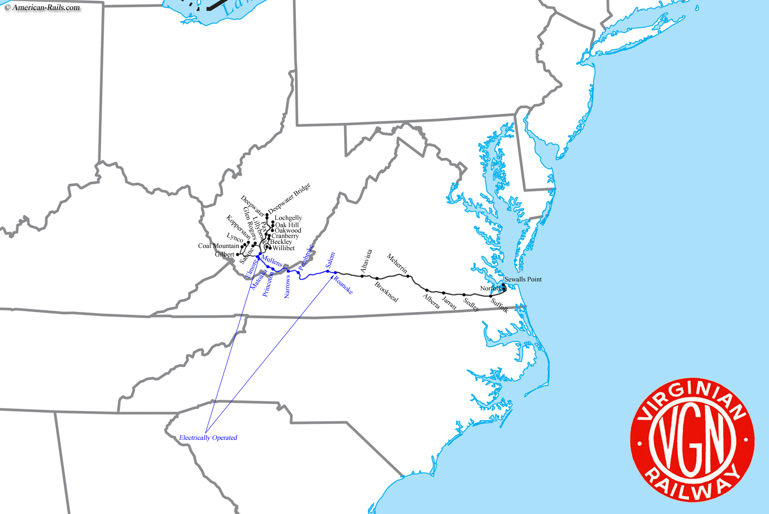
It headed eastward through Virginia's western mountains, crossed the Piedmont's rolling hills, and finally terminated in the coastal plains. While construction was ongoing the Tidewater and Deepwater systems were merged into the new Virginian Railway during March of 1907. Like the N&W, Roanoke became an important location. It was reached in 1906 and already growing thanks to the Norfolk & Western. Here, a major terminal was established along the north bank of the Roanoke River. The city was also the terminus of its Western Division (Roanoke - Deepwater) and Eastern Division (Roanoke - Norfolk) in addition to being the eastern-most point of its electrification. As construction continued the main line was opened from Deepwater to Norfolk in April of 1909. Engineered to extremely high standards, as Mr. McBride notes, trains literally traveled down hill from West Virginia all of the way into Norfolk leaving empties to make the climb back to the mines. The worst grade along the entire 422-mile main line was between Mullens and Matoaka at 2.07%. Just nine miles away from Norfolk two coal piers were constructed at "Sewalls Point" (today, commonly spelled Sewell's Point) to handle export coal shipments. These structures were more than 1,000 feet in length and, combined, could empty 23 loaded trains each day equating to roughly 232,000 tons.
A massive Virginian 2-6-6-6 (AG), #903, is seen in a Lima Locomotive Works builder's photo circa 1945. Only the VGN and C&O used this powerful wheel arrangement.
Passenger service launched in May between Roanoke and Deepwater with trains running the railroad's entirety by July 1st. They were modest affairs but continued to offer parlors, diners, and Pullman's until August of 1932 when unnamed #3 and #4 became coach-only consists. Years later a single baggage and coach (rented from the N&W) did the honors. As H. Reid's article, "Of Black Upholstery And Commanding Exhaust" from the August, 1956 issue of Trains Magazine points out the final runs occurred on January 29, 1956. They witnessed a flurry of nostalgic patrons, helped by railfans belonging to the local Tidewater Chapter of the National Railway Historical Society. The additional interest required the need for an extra coach. But coal, of course, always paid the bills; roughly 17.5 million tons of freight was handled in 1948 and black diamonds comprised 88%. Until 1931 it had relied on a single connection at Deepwater with rival Chesapeake & Ohio.
That year it completed a bridge across the Kanawha River which provided for a much more receptive interchange with the New York Central. This transformed the Virginian from simply a coal road to a prominent player in the Midwestern gateway enabling the introduction of time freights. No longer did the N&W and C&O have exclusive rights in this regard. The bridge also slightly improved passenger services by allowing trains to reach Charleston's Smith Street Union Station which was also served by the Baltimore & Ohio and NYC.
The railroad designated them as EL-3a, EL-2a, and EL-1a although their only difference was the number of units operating together (i.e., EL-3a's operated in threes, EL-2a's in twos, and EL1-a's as a single unit). Most often they operated in sets of three as class EL-3a and could produce an impressive 6,000 horsepower and 231,000 pounds of tractive effort. The latter was in part due to their large size, weighing in at over 1.2 million pounds with a length of 152 feet and 3 inches. In all, the Virginian owned 16 of these early boxcabs; ten of the EL3a class numbered 100-109 and six of the EL-1a class numbered 110-115. The lone EL2-a, numbered 100, was later reclassified as an EL-3a. The Virginian’s boxcabs used the early side-rod design in transferring power to the driving wheels. The locomotives used what were called "phase converters" to turn single-phase AC transmission into three-phase for use by its large induction motors. They remained the sole motors until the late 1940's when new units began arriving.
. Its first purchase came in 1948 when it took delivery of four units known as AC rectifiers. This technology was truly exceptional for its time enabling the inherent advantages of AC, which was then converted to high-adhesion DC. According to the book, "Electric Railways: 1880-1990" by Michael Duffy, rectifiers provided the following advantages:
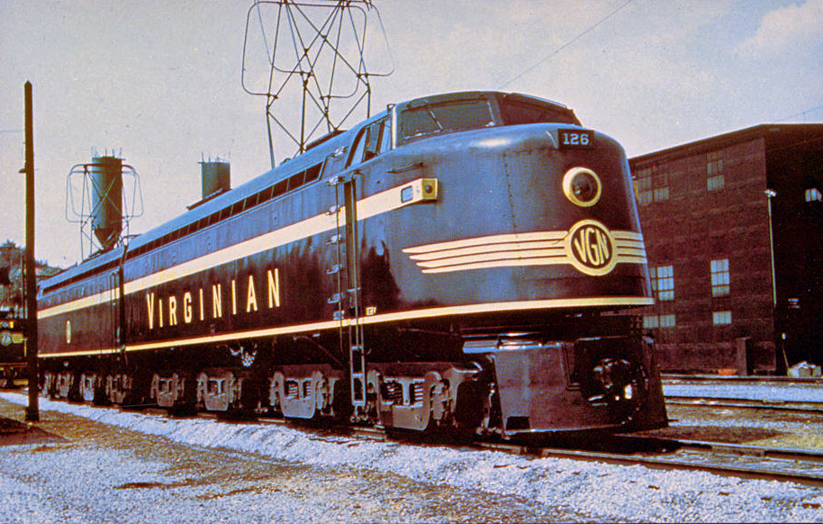Virginian Railway EL-2B set #126 sits on display in Roanoke, Virginia during the National Railway Historical Society's 1957 convention.
Financed by Henry H. Rogers, one of the wealthiest men in the world, the Virginian proved itself as a modern well engineered railroad that could operate more efficiently than its larger competitors.
The Virginian Railway extended from Sewells Point, on Hampton Roads, Norfolk, Virginia, to Deepwater, West Virginia, a distance of 443 miles. It existed from 1909 until 1959, when it was bought out by Norfolk and Western.
Directness of route was the primary goal of the engineers who planned the path of the Virginian. To achieve this objective, the mountainous terrain had to be overcome by the construction of a series of tunnels, bridges, and cuts. More attention was paid to grades and alignment than had ever been done in the building of a railroad. Cost was of no consideration. ” Nothing is too good for my railroad,” said the founder, Henry Huttleston Rogers.
Plans were for this railroad to be a scientifically constructed and equipped railroad. Revolutionary concepts and ideas were put into action. Unlike the practice of the more established rail systems in routing their lines expressly to reach populated locations, with passenger traffic the primary goal of their service; constructing them a piece at a time as money was available, the Virginian was built with the resources of one man – H.H. Rogers- who planned his railroad to utilize the fastest route for coal hauling. The building of the Virginian became the model for railway improvements for some of the oldest and largest systems in the country.
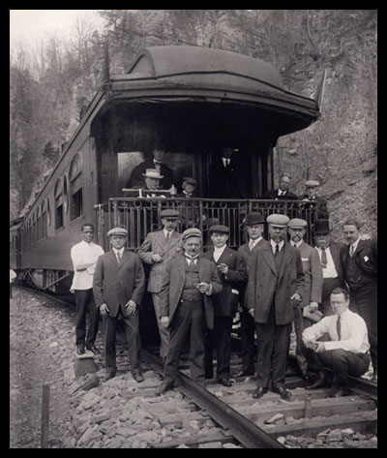
The work of building the Virginian Railway began in West Virginia in the name of the Deepwater Railway Company. Rogers named William N. Page president of the newly formed organization. When Rogers took a hand in directing the affairs of the Deepwater, his first act was to have its charter amended to extend to the West Virginia boundary line. The company’s charter was revised in September, 1902. In approximately a year and five months, the Tidewater Railway was chartered in the state of Virginia with its boundary extended to the line of the two Virginias that would connect the two Railways.
W. N. Page became president of both railways. Rogers’ ownership of the two projects did not become known until 1907 when the Virginian Railway was incorporated.
Sixty four percent of the excavation in West Virginia consisted of solid rock. The majority of the excavation was done by hand labor, mules and carts. Upwards of 50 steam shovels, 1,200 dump cars, and 124 locomotives were used in the excavation of the cuts and tunnels. At the height of the construction more than 10,000 laborers were employed.
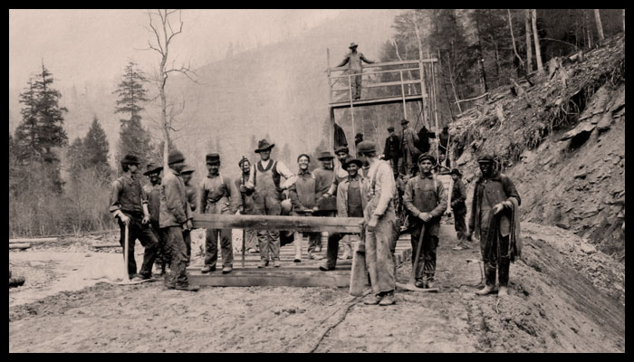
At the time the Virginian began construction, there was not a single mine development on the main line. By 1933, 91 mines were developed by the Virginian. It shared in the development of 47 mines on connecting lines which it acquired or built for a total of 138 working mines.

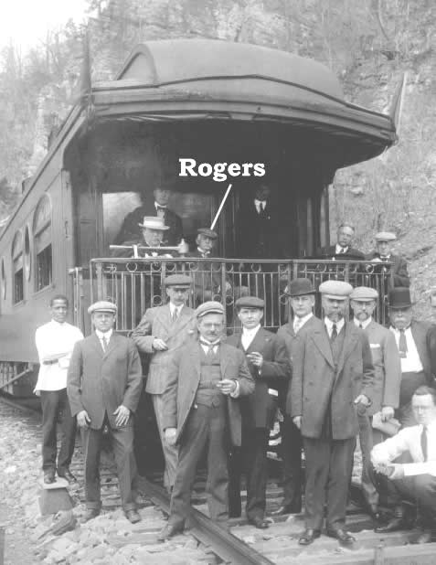
In the crowning achievement of his lifetime, Rogers rode the rails on an inspection tour across the Virginias. The tour brought thousands to trackside. The following month Henry Rogers died. However, his Virginian Railway was destined for success as the leading coal transport in the region and in 1959, the much coveted Virginian became part of the Norfolk and Western Railroad, headquartered in Roanoke, Virginia.

For its initial electric locomotives, the railroad turned to Alco and Westinghouse; Westinghouse specialized in AC transmission whereas at the time, General Electric preferred DC transmission. While rather simple looking in outward appearance, these three section locomotives could provide tremendous amounts of power, 7,125 hp and 231,000 pounds of tractive effort. The locomotive’s tremendous tractive effort was in part due to its large size, weighing in at over 1.2 million pounds with a length of 152 feet and 3 inches. Initially, Virginian received and operated twelve of these three section locomotives, spending $4,646,292. Within a few years, the last one was divided into three single section locomotives for switching and yard work. During the years of their lifespans, a couple others were separated and then reunited again. Virginian added more electric locomotives of different designs in 1948 and 1956-57.

After Virginian’s merger with N&W December 1, 1959, N&W made a token effort to utilize the Virginian’s electric locomotive fleet. The electrics didn’t fit in; they could only be used on a section of the former Virginian line and N&W had cast its lot into the diesel electric locomotive camp earlier. In June 1962, the last train to operate over the old Virginian with electric locomotives made its last run into Roanoke. The engines were a trio of five years old General Electric, 3300 horsepower, class EL-C class locomotives. With no purpose to serve, the Narrows Power Plant was demolished in 1970.

Crew
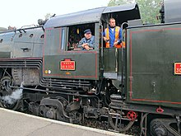
A locomotive crew in France
A steam locomotive is normally controlled from the boiler's backhead, and the crew is usually protected from the elements by a cab. A crew of at least two people is normally required to operate a steam locomotive. One, the train driver or engineer (North America), is responsible for controlling the locomotive's starting, stopping, and speed, and the fireman is responsible for maintaining the fire, regulating steam pressure and monitoring boiler and tender water levels.
Locomotives have their own braking system, independent from the rest of the train. Locomotive brakes employ large shoes which press against the driving wheel treads
Companies manufacturing locomotives in the US included Baldwin Locomotive Works, American Locomotive Company (ALCO), and Lima Locomotive Works. Altogether, between 1830 and 1950, over 160,000 steam locomotives were built in the United States, with Baldwin accounting for the largest share, nearly 70,000.^{[71]}

The introduction of electric locomotives around the turn of the 20th century and later diesel-electric locomotives spelled the beginning of a decline in the use of steam locomotives, although it was some time before they were phased out of general use.^{[74]} As diesel power (especially with electric transmission) became more reliable in the 1930s, it gained a foothold in North America.^{[75]} The full transition away from steam power in North America took place during the 1950s.
Compared to steam, diesel power reduced maintenance costs dramatically while increasing locomotive availability. On the Chicago, Rock Island and Pacific Railroad, new units delivered over 350,000 miles (560,000 km) a year, compared with about 120,000–150,000 miles (190,000–240,000 km) for a mainline steam locomotive.^{[39]} World War II delayed dieselisation in the US until the late 1940s;

Step-by-step
It's easiest to see how everything works in our little animation of a steam locomotive, below. Inside the locomotive cab, you load coal into the firebox (1), which is quite literally a metal box containing a roaring coal fire. The fire heats up the boiler—the "giant kettle" inside the locomotive.
Coal was a cheap and abundant fuel during the early Industrial Revolution, but the invention of the gasoline engine (petrol engine) in the mid-19th century heralded a new era: during the 20th century, oil overtook coal as the world's favorite fuel. Steam engines are extremely inefficient, wasting around 80–90 percent of all the energy they produce from coal. That means they have to burn enormous amounts of coal to produce useful amounts of power.
A steam engine is so inefficient because the fire that burns the coal is totally separate (and often some distance from) the cylinder that turns the heat energy in the steam into mechanical energy that powers the machine. This design is called an external combustion engine because the fire and boiler are outside the cylinder. It's inefficient because energy is wasted as the heat and steam travel from the fire, via the boiler, to the cylinder. Gasoline- and diesel-powered engines are based on a totally different design called an internal combustion engine. The gasoline or diesel fuel is burned inside the cylinder, not outside it, and this makes internal combustion engines considerably more efficient. (You can read more about internal and external combustion in our overview of engines.) Oil has many other advantages too: it's cleaner than coal, makes less air pollution, and is much easier to transport in pipes.
That's largely why steam locomotives disappeared from our railroads—diesel locomotives were
Like a gasoline engine, a diesel engine is a type of internal combustion engine. Combustion is another word for burning, and internal means inside, so an internal combustion engine is simply one where the fuel is burned inside the main part of the engine (the cylinders) where power is produced. That's very different from an external combustion engine such as those used by old-fashioned steam locomotives. In a steam engine, there's a big fire at one end of a boiler that heats water to make steam. The steam flows down long tubes to a cylinder at the opposite end of the boiler where it pushes a piston back and forth to move the wheels. This is external combustion because the fire is outside the cylinder (indeed, typically 6-7 meters or 20-30ft away). In a gasoline or diesel engine, the fuel burns inside the cylinders themselves. Internal combustion wastes much less energy because the heat doesn't have to flow from where it's produced into the cylinder: everything happens in the same place. That's why internal combustion engines are more efficient than external combustion engines (they produce more energy from the same volume of fuel).
Gasoline engines and diesel engines both work by internal combustion, but in slightly different ways. In a gasoline engine, fuel and air is injected into small metal cylinders. A piston compresses (squeezes) the mixture, making it explosive, and a small electric spark from a sparking plug sets fire to it. That makes the mixture explode, generating power that pushes the piston down the cylinder and (through the crankshaft and gears) turns the wheels. You can read more about this and watch a simple animation of how it works in our article on car engines.
Diesel engines are similar, but simpler. First, air is allowed into the cylinder and the piston compresses it—but much more than in a gasoline engine. In a gasoline engine, the fuel-air mixture is compressed to about a tenth of its original volume. But in a diesel engine, the air is compressed by anything from 14 to 25 times. [1] If you've ever pumped up a bicycle tire, you'll
The boiler (2) in a steam locomotive doesn't look much like a kettle you'd use to make a cup of tea, but it works the same way, producing steam under high pressure. The boiler is a big tank of water with dozens of thin metal tubes running through it (for simplicity, we show only one here, colored orange). The tubes run from the firebox to the chimney, carrying the heat and the smoke of the fire with them (shown as white dots inside the tube). This arrangement of boiler tubes, as they are called, means the engine's fire can heat the water in the boiler tank much faster, so it produces steam more quickly and efficiently. The water that makes the steam either comes from tanks mounted on the side of the locomotive or from a separate wagon called a tender, pulled behind the locomotive. (The tender also carries the locomotive's supply of coal.) You can see a photo of a tender showing its water tank further down this page.
The steam generated in the boiler flows down into a cylinder (3) just ahead of the wheels, pushing a tight-fitting plunger, the piston (4), back and forth. A little mechanical gate in the cylinder, known as an inlet valve (shown in orange) lets the steam in. The piston is connected to one or more of the locomotive's wheels through a kind of arm-elbow-shoulder joint called a crank and connecting rod (5).
As the piston pushes, the crank and connecting rod turn the locomotive's wheels and power the train along (6). When the piston has reached the end of the cylinder, it can push no further. The train's momentum (tendency to keep moving) carries the crank onwards, pushing the piston back into the cylinder the way it came. The steam inlet valve closes. An outlet valve opens and the piston pushes the steam back through the cylinder and out up the locomotive's chimney (7). The intermittent chuff-chuff noise that a steam engine makes, and its intermittent puffs of smoke, happen when the piston moves back and forth in the cylinder.
There's a cylinder on each side of the locomotive and the two cylinders fire slightly out of step with one another to ensure there's always some power pushing the engine along.

