LOCOMOTIVE ENGINES OF THE
“RICHEST LITTLE RAILROAD IN THE WORLD”
The profitable Virginian Railway experimented with the finest and largest steam, electric, and diesel locomotives. It was well known for operating the largest and best equipment. It was so profitable it could afford the best. VGN sought (and achieved) the best efficiencies in the mountains, rolling piedmont and flat tidewater terrain.
It became nicknamed "the richest little railroad in the world."
Through the course of its 50 year history as the “richest little railroad”, the Virginian used three types of engines to haul coal trains from the mountains of WV to the Tidewater area of Virginia to awaiting ships. The Virginian even had its own tugboat to help bring the large ships into the harbor at Sewell’s Point, VA.

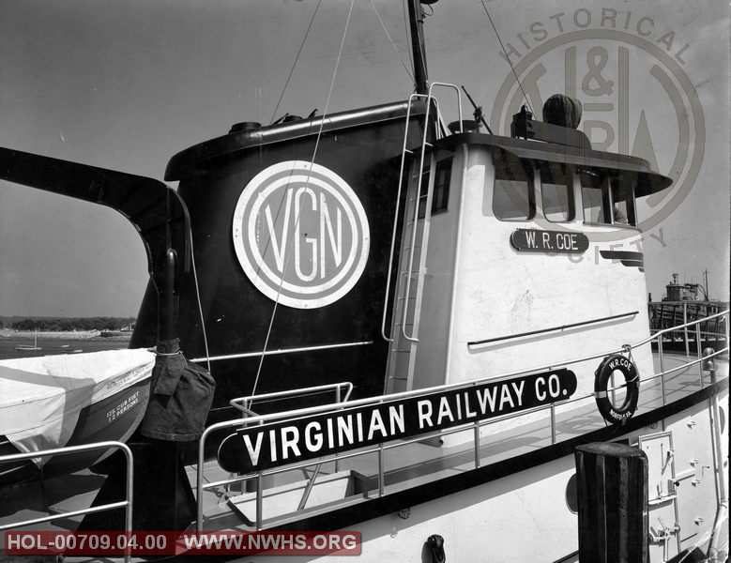

STEAM LOCOMOTIVES
The first type of engine that the Virginian used from its inception was the steam engine. The first railroads were little more than tracks on roads; horses pulled wagons and carriages with their wheels modified to ride on the rails. Trains could not be moved by steam power until the steam engine could be mounted on wheels. The first steam locomotives were built in England, the birthplace of steam power, and the first locomotives in America were imported from England. Soon, however, Americans began to plan their own locomotives.

How a steam engine works
Basically, there are four different parts in a steam engine:
- A fire, where the coal burns.
- A boiler full of water that the fire heats up to make steam.
- A cylinder and piston, rather like a bicycle pump but much bigger. Steam from the boiler is piped into the cylinder, causing the piston to move first one way then the other. This in and out movement (which is also known as "reciprocating") is used to drive...
- A machine attached to the piston.
- The piston is attached to the wheel and makes it turn.
- The wheel moves forward.
- 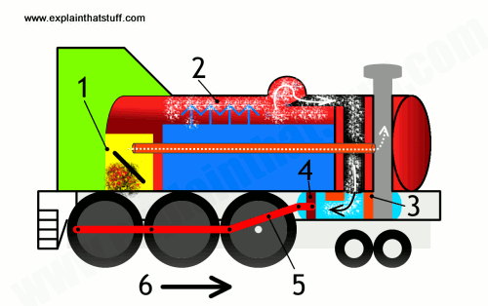

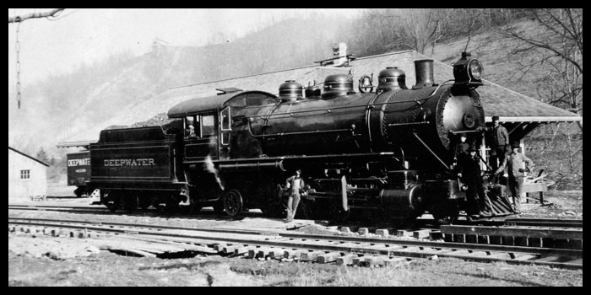
One of the Deepwater’s early locomotives. The Deepwater combined with the Tidewater to form the Virginian Railway in 1909.
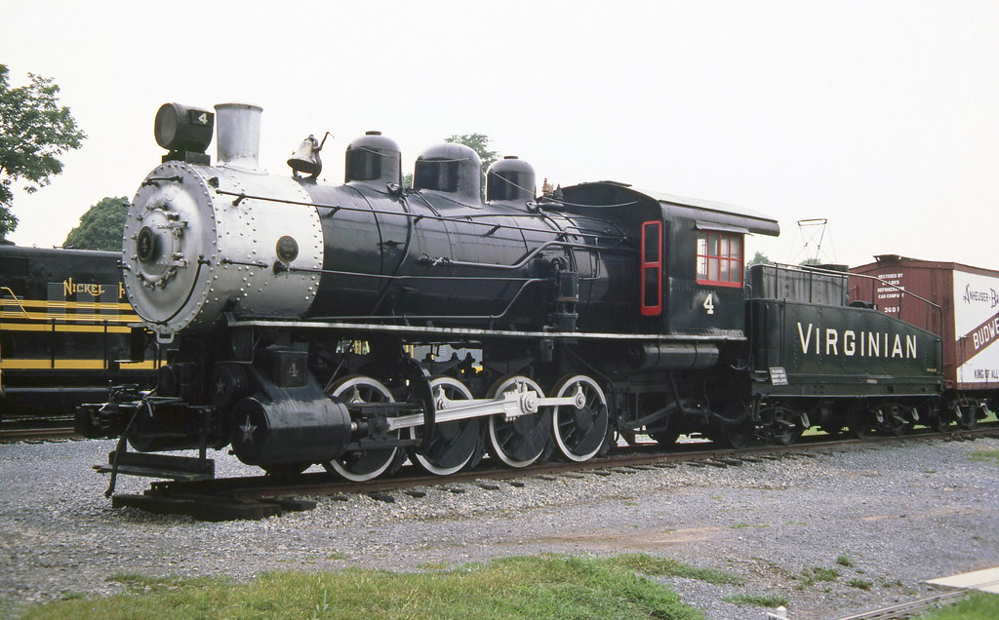
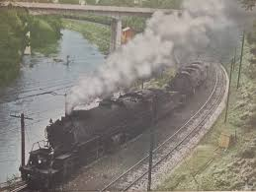
From the early 1900s, steam locomotives were gradually superseded by electric and diesel locomotives, with railways fully converting to electric and diesel power beginning in the late 1930s. The majority of steam locomotives were retired from regular service by the 1980s, although several continue to run on tourist and heritage lines.

Operating and Electrifying "the Richest Little Railroad in the World"
After completion of the railroad, the Virginian Railroad ran into a problem at Clark’s Gap in Wyoming County, WV. The mountain was impenetrable and the grade was very steep. The steam engine, hauling a load of coal cars, could only go about 14 miles per hour up the grade. Since time was money to the coal barons, the Virginian found a way to speed up that route. Proponents argued that electric-powered trains were cleaner, quieter and more efficient to operate. Electric motors provided greater starting power than steam power. And, electrified operations could lower labor costs and increase speed because there was no need to stop for coal, oil and water.
At the railroad’s Board of Directors meeting in the spring of 1923, it was decided to commence work to electrify a 134 mile portion of the main line. Engineering and design work commenced Nov. 29, 1923 .One hundred and thirty four miles of the mainline would be electrified. To electrify a railroad, you needed a source of power, so the Virginian started building a power plant in Narrows, VA. To construct the overhead and functioning electric lines for the 133.6 miles of electrified railroad, the railroad directors approved $5,964,973 for catenary in Virginia and $1,977.292 for catenary in West Virginia. A catenary is a system of overhead wires used to supply electricity to a locomotive or streetcar.
Narrows, Virginia was chosen as the site for the power plant because the town was already there and it was half way between the extreme ends of the electrified territory; Mullens and Roanoke. The plant’s primary building was 220 feet by 156 feet and roughly 140 feet high. Two brick stacks stood 376 feet tall. There were three turbo generators with a fourth available as needed, each capable of producing 15,000 k.w of electricity.

As an illustration of the output of the Narrows Power Plant operation, the 45,000 kilowatts to 60,000 kw produced at the plant in 1925, before any upgrades or modifications, would be sufficient to power the entire City of Princeton, West Virginia in 2010.

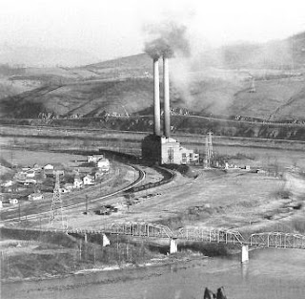
Former VGN coal fired power plant located at Narrows, VA, about seven miles east of Glen Lyn. The plant supplied electricity for the entire electrified territory. It was shut down on June 30, 1962 at the end of electrification. The structure was dismantled in the early 1970’s

The electrification was completed in 1925 at a cost of $15 million, equal to $221,356,736 today. ALCO and Westinghouse supplied the first electric boxcab-style locomotives, which were equipped with pantographs, as shown below.

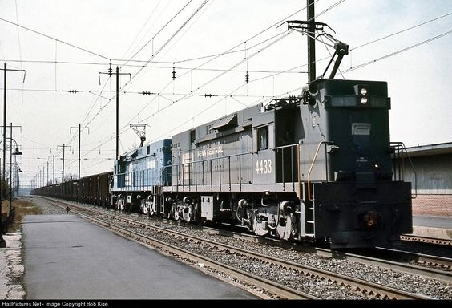
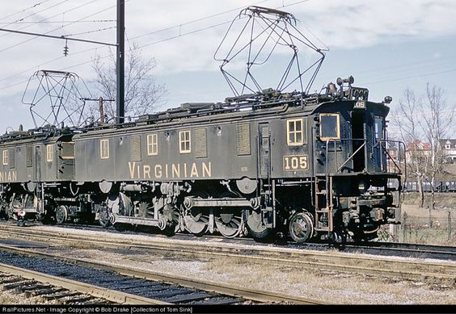

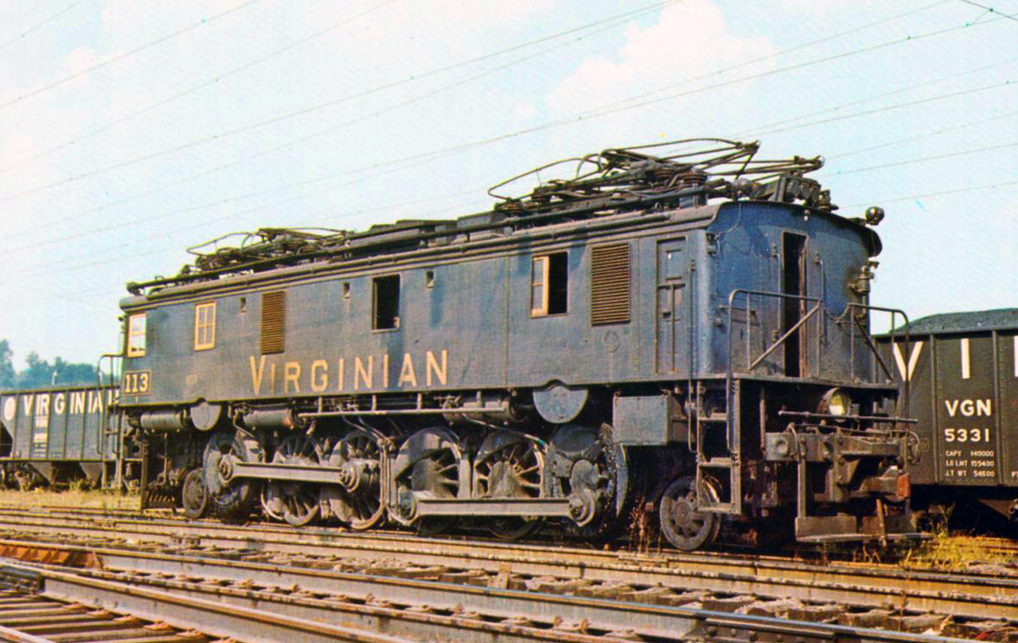
Virginian Railway boxcab #113 (Class EL-1a) sits quietly under the wires at Princeton, West Virginia circa 1957.

The Virginian's electrification constituted the longest stretch of mountainous electrification in the eastern United States. The electrification project was written up extensively in the railroad trade press at the time
Skeptics balked at the expense of building generating plants and maintaining a spider web-like network of overhead catenary wires. They also raised safety concerns about the hazards posed by high-voltage lines. In almost every instance, electrification was beneficial to the bottom line. Running times were reduced and tonnage capacities were increased. Fuel and maintenance costs were lowered, and the service lives of electric locomotives proved to be twice as long as those of steam locomotives.
According to Thomas Edison, electric locomotives offered numerous advantages, including “no grinding, no jerking, no puffing, no pulling, no straining, no distant slumbers—just a keen sense of moving swiftly, of being propelled by power vastly in excess of requirements. You ride with ease—you are at ease—it is the very last word in transportation.” The heyday of all-electric locomotives ended after World War II with the advent of reliable, cost-effective diesel machines. The 1950s was a transition decade for the railroad industry as steam power quickly succumbed to diesel technology, which offered numerous advantages.

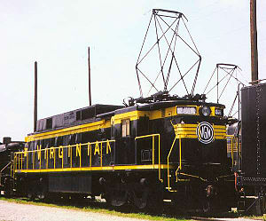
EL-C
To supplement its aging boxcabs, which were reliable and effective, but hard on the track, the Virginian turned to General Electric. In 1948, four huge EL-2B twin-unit locomotives were purchased followed by twelve EL-C rectifier locomotives in 1955.
The Virginian Railway’s EL-C rectifiers were the most advanced electric locomotives the railroad ever owned.
Built in the late 1950s by General Electric, they produced over 3,000 hp and were quite adept at hauling coal out of the southern West Virginia mountains.

THE “Richest Little Railroad” converts to DIESEL
In the mid-1950s VGN management realized that the company's devotion to coal as its energy source (for steam locomotives and the power plant at Narrows for the electrification system) was becoming overshadowed by the economies of diesel-electric locomotives and a scarcity of parts for the older steam locomotives. Many railroads engaged in long-term experimentation during the era of dieselization, ordering a few units from each of the several builders of the day. The Virginian went totally the other direction, ordering diesels from Fairbanks Morse almost exclusively. The lone exception was one General Electric 44-Tonner, purchased specifically for industrial and interchange service in the Suffolk, VA area.
The VGN built these to the heaviest standards of the time in order to accommodate the heavy tonnage which it hauled.
Diesels were easier to operate and required only one operator, which provided greater ease in switching and yard operations. They were quieter, operated in all types of weather, and offered climate-controlled cabs for an improved work environment. Diesels were altogether more convenient. It takes hours to fire up a steam engine before you can use it; you can get a diesel engine running in less than a minute and they incurred no costs due to downtime

Between 1954 and 1957, a total of 66 diesel-electric locomotives were purchased, including 25 Fairbanks-Morse H-24-66 Train Masters, and 40 H-16-44 smaller road switchers, two with steam generators to haul passenger trains. The last steam locomotive operated in June, 1957.
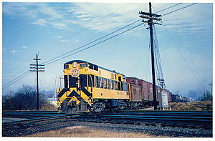
At the end of 1925, VGN operated 545 route-miles on 902 miles of track; at the end of 1956, mileages were 611 and 1089.
The VGN was merged into the Norfolk & Western in 1959. However, almost all of the former VGN mainline trackage in West Virginia and about 50% of that in Virginia is still in use today, as the preferred route for eastbound coal trains for Norfolk Southern Corporation due to the more favorable gradients while crossing the Allegheny Mountains' continental divide and the Blue Ridge Mountains east of Roanoke, while most westbound traffic of empty coal cars uses the original Norfolk and Western main line.

