Princeton Agricultural Museum
RAILWAY EXPRESS AGENCY BUILDING
Express delivery in the early 19th century was almost all by horse, whether by stagecoach or riders. The express business flourished in the latter half of the 19th century and by 1900 there were four principal parcel express companies, all of which included the rapidly advancing railways, as one of their means of transport.
In 1909, two years after the Virginian Railway started operations between Sewell's Point near Norfolk, VA to a point in WV called Deepwater, the railroad built the American Railway Express Company building.
The building was of wood construction and was used to receive goods shipped by rail for businesses in Mercer County and surrounding communities.
During the winter of 1917, the United States suffered a severe coal shortage. On December 26, 2017, President Woodrow Wilson commandeered the railroads on behalf of the United States government to move federal troops, their supplies, and coal. All the railway line were then consolidated for the war effort.
All contracts between express companies and railroads were nullified and all existing express companies were consolidated into a single company to serve the country's needs. The result was a new company called the American Railway Express Agency, which was formed in July 1918. The new entity took custody of all the pooled equipment and property of existing express companies.
The American Railway Express Agency, was a national package delivery service that operated in the United States from 1918 to 1975. REA arranged transport and delivery via existing railroad infrastructure, much as today's UPS or Fedx companies use roads and air transport. It was created through the forced consolidation of existing services into a national near-monopoly to ensure the rapid and safe movement of parcels, money, and goods during World War I. Following the end of World War I, the railroads were returned to their private sector owners via an act of Congress (the Transportation Act of 1920). However, the express businesses were not; they remained a part of the American Railway Express Company. A less well-known clause in the legislation made American Railway Express a private corporation.
The formation of REA
On December 7, 1928, 86 of the nation’s railroads established Railway Express Agency, Inc. More than a decade after the end of World War I, REA bought out the American Railway Express Company in March 1929 and operated the express business under the joint private ownership of the railroads.
With its trademark red-diamond sign, green delivery trucks, baggage carts, and railroad equipment, REA was a common sight across communities large and small.
Soon after REA was founded, the classic red diamond logo debuted. The iconic emblem remained unchanged during the next four decades. REA also retained the red and green colors used previously by American Railway Express Company.
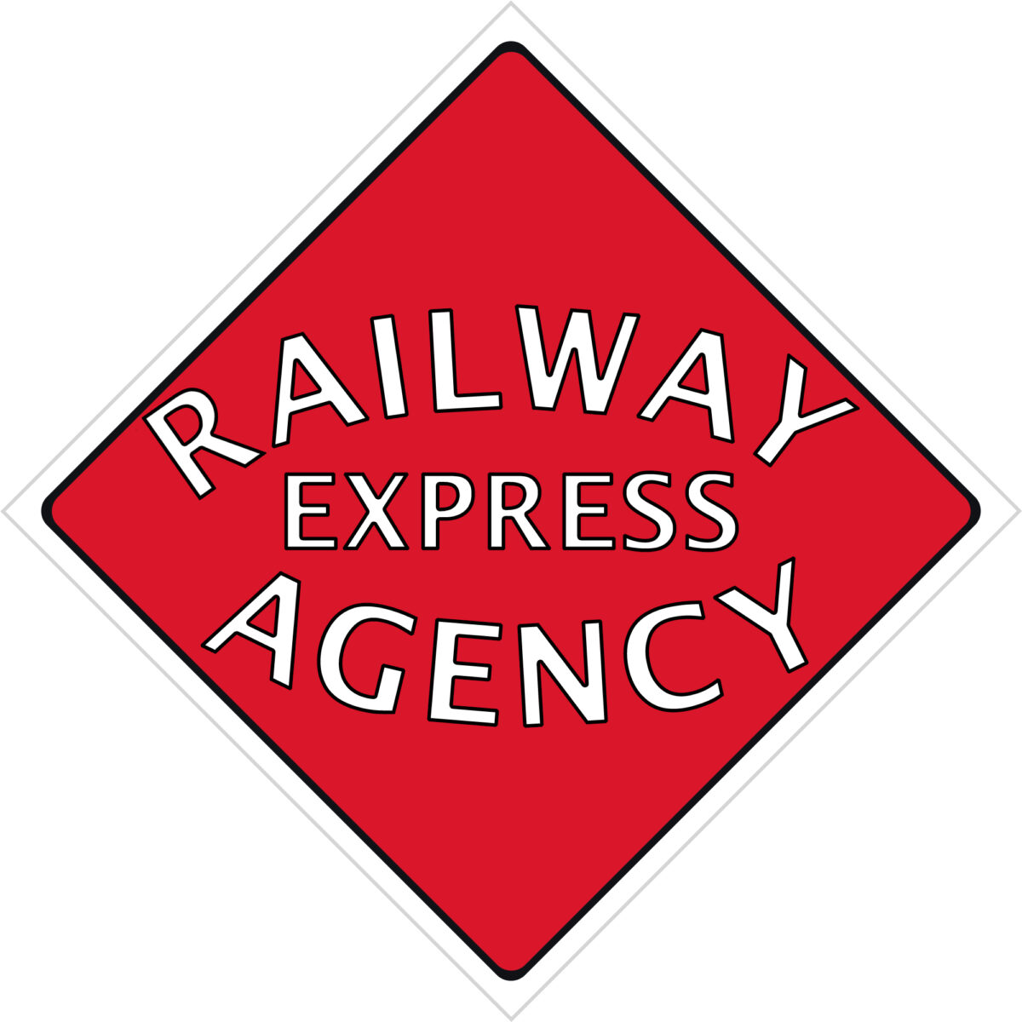
The railroads provided railcars, as well as space at their terminals and stations to REA. The REA railcars were moved by the railroads at their expense on their regularly scheduled trains. The REA was an industry monopoly; it was the sole express business to move goods via rail. A wide variety of products were shipped via REA, including animals, hazardous materials, explosives, and even fruits and vegetables. Goods carried by REA could be picked up at the railroad station or delivered by independent businesses.
In time, REA expanded across the U.S. with thousands of small offices located nationwide. People came to depend on REA for their shipping needs. Until the early 1960s, REA provided a tremendous service; it was a third-party that handled all express shipments, so that the railroads did not have to deal with the shipments themselves.
Alas, things crumbled after World War II, which coincided with a rapid decline in rail travel.
After the original railroad station was torn down, the only building left in the Princeton Railroad yard, was the American Railway Express Building. It was scheduled to be torn down to make room for a railroad crossing to the new WV recycling company, which is located in the only remaining building of the Virginian Railroad Shops.
At this time, City Manager Doug Freeman, who was responsible for building the new Princeton Railroad Museum, was also interested in preserving the old American Railway Express Building. He approached Frank Nash, president of the Mercer County Farm Bureau and a member of the planning board for the new museum, to see if he had any idea of how the building could be saved. Mr. Nash suggested an Agricultural Museum, to tie in with the Railroad Museum and Mr. Freeman agreed. With the approval of the Princeton City Council, a lease was drawn up for the building and land.
The building was moved from the original location where the road is now to its current location in May of 2003. (insert picture of moving building).

The building has been restored and now houses the Agricultural Museum and the offices of the Mercer County Farm Bureau.
Many of the older implements no longer used on farms are now featured in the Agricultural Museum.
(Insert picture of washer/churn)
This wringer washer was designed to do double duty as a butter churn. Remove the agitator and replace with the churn insert (as shown here) and agitate to make butter, saving a lot of time for the farm wife.
(Insert picture of incubator)
An incubator to keep the eggs warm, so that they might hatch without laying under the mother hen. When a mother hen is “brooding”, she will not continue to lay eggs. Taking them out of the nest and putting them in an incubator will change her hormone levels and she will start to lay eggs again.
(insert picture of chicken beak cutter aka debeaker)
Chicken beak trimming, is a partial removal of the beak of poultry, especially layer hens. When layer hens are confined to a chicken house, farmers generally trim their beaks to prevent them from pecking (and possibly hurting) one another. While the term debeak implies that the entire beak is removed, in fact usually less than a third of the upper beak is trimmed, and not the whole beak.

